Lab-12 Indexing

Output

Before Indexing

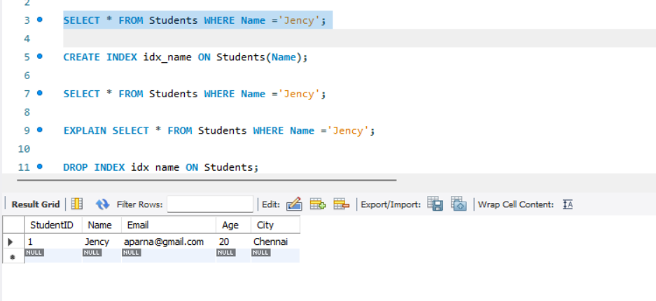

After Intexing

